1. Introduction
   1. Purpose of this Document

The purpose of this document is to provide a high level overview of the software design for the product being developed, Asset Tracker. Within this document will be information regarding data design, system architecture, software components and the user interface.

* 1. Scope of the Development Project

The product being developed will called Asset Tracker. The benefit provided by the software is having a resource for all employees to have information on the technology related assets that are relevant to them. With the exception of IT users, who will have the ability to see all employees and the assets assigned to them, a user will have the ability to see what devices are assigned to them as well as any devices assigned to any of their direct reports. Users will also be able to request new devices or put in a support ticket for a device they currently have. IT users will be the ones managing the system. They will be able to add or remove users and devices.

* 1. Definitions, Acronyms and Abbreviations

Not applicable.

* 1. References

Asset Tracker SRS (Lawal, Richer, Rogers)

* 1. Major software requirements

A MySQL database on a local server.

* 1. Design constraints, limitations
     1. Design Constraints

Must be able to be easily installed regardless of existing IT infrastructure. User client must be able to work on both Windows and OSX.

* + 1. Limitations

Not applicable.

* 1. Changes to requirements

Not applicable.

* 1. Overview of document

Outlined in this document will first be the data design. There the objects and data structures that will be used will be described in depth. Also included will be the database schema and the file structure. Following that will be the system architecture description. That will include the description of how of the parts mentioned in the data design portion of the document will function within the system and how they interact with one another. Next will be a detailed description of components. For all components of the system there will be a breakdown of their function and purpose as well as the parts that will make up the component. Lastly there will be the interface design. That section will provide a view into the user experience for all different types of users of the system.

1. Data Design
   1. Data Objects and resultant data structures

For a given user session there will be multiple instances of three data objects, Device, User and Request. A Device object will have these attributes:

* Type: String
* Description: String

An User object will have these attributes:

* firstName: String
* lastName: String
* email: String
* phone: String
* permissionLevel: String
* devices: [Device]
* reporters: [User]
* requests: [Request]

A Request object will have these attributes:

* user: User
* deviceType: String
* description: String
* neededBy: Date
* approved: Boolean
  1. File and database structures
     1. External file structure

There will be a MySQL database with this schema:

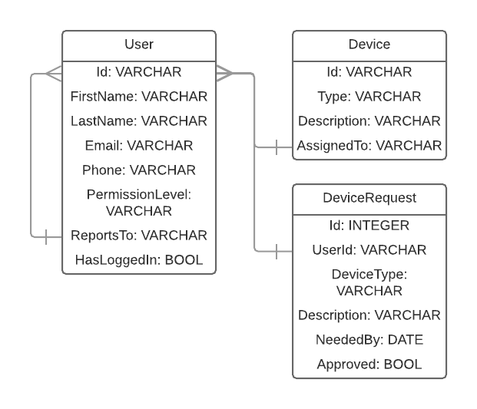

* + 1. Global data

Not applicable.

* + 1. File and data cross reference

Not applicable.

1. System Architecture Description
   1. Overview of Modules / Components

Since the program is meant to be simple and easy to use there aren’t many components and subsystems.There will be a login, and if you are an admin or not will determine what the dashboard will end up looking like. Basically a regular user will only have read access to the database. And admins will have full read/write. Admin page will have the ability to add an entry, edit an entry, delete, etc. Users will only be able to see their devices that are tied to their account. The front end will be a simple design with a my device’s page where entries can be modified. The front end will sit on top of a database where all the information is going to be stored. When an interaction is established on the front end it will talk and depend on the database to execute the command.

* 1. Structure and relationships

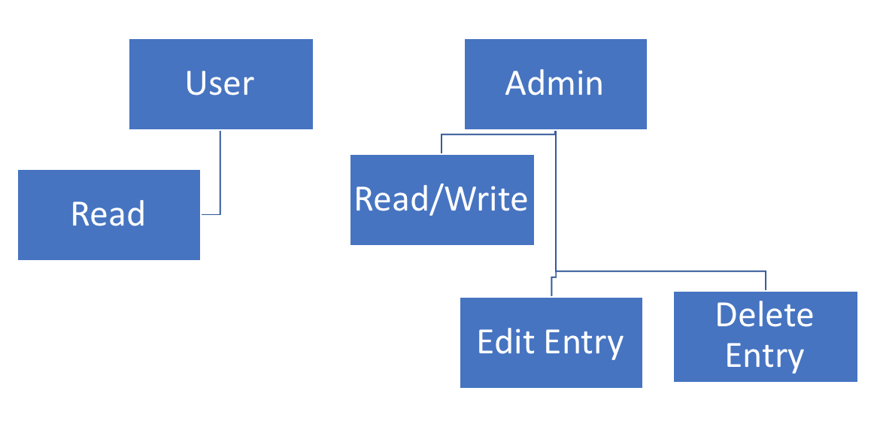

1. Detailed description of components
   1. Component template description

**Identification**: Add Entry/Edit

**Type**: control procedure

**Purpose**: Allows the user to add an entry into the system to store. The entry would then be accessible from there on out. Once it is in the entry can then be edited.

**Function**: Adding an entry will require the name of the user, the device they are adding, and any important information needed to track for that specific person-device relationship.

**Modules Used**: N/A

**Dependencies**: This component can only be run if an admin is logged in. Will not work if regular user is using it. Has to have the database in order for it to be stored. If the database is down an entry cannot be added or changed.

**Resources**: Database, Internet, System Services

**Processing**: If

**Data**: Will start out as a person having an entry value of null. They do not exist until created. Once they are created they will have a value of 0. If a device is added under their name it will change to 1, etc.

* 1. Description of [Component #1]

See above

1. Interface Design

When the application is opened there will be a logon screen. If the user enters incorrect credentials they will be alerted that they are incorrect. If the user is logging in for the first time they will be prompted to change their password from the temporary that was set when the account was created. When all users enter their correct credentials they will brought to page that lists all of their devices called the My Devices Page. There will be a button next to all listed devices that when clicked will bring up the user to a page where they can submit an IT support ticket for that device. That page will have a text box that will allow them to describe the issue they are having. Also on the page that lists the user’s devices there will be a button to request a new device. If clicked the user will brought to a page where they can fill out a form to send a ticket for that device. The fields on the form will be Device Type, Description and Date Needed By. Once the request is submitted the user will see the status of the Requests page which will be reachable from the main My Devices page. Also on that page will be any requests submitted by users who report to the logged in user. If the user clicks on a request from a user who reports to them they will see the device that is being requested along with the request description. Then they will be able to click a button to approve or deny the request. If the user is an IT user, on the Requests page they will see all approved requests and they close them out once they have been fulfilled. Also accessible from the My Devices page will be the Devices page. There users will be able to see the devices assigned to the users who report to them. If a user is an IT user they will be able to see all devices on the page. Two pages that will only be accessible to IT users will be the Add User page and the Add Device page. The Add User page will be used to add new users. On the Add User page will be a form where the user will enter the new user’s first and last name, their email address, their phone number, who they report to, their permission level and temporary password for their first login. On the Add Device page there will be a form where the user will enter the device’s ID, type, description and who it is assigned to. If a device does not have an assigned user, the device’s user will be listed as Inventory. A user may have as many devices tied to their name as they want. Once a device is no longer in use (where it is too old or broken) an admin will be able to go in and delete it from the system.